Area Servizi agli Studenti e Internazionalizzazione  Ufficio Mobilità e Relazioni Internazionali  Via Pieragostini 18 - 62032 Camerino (MC)  tel. 0737 404611- fax 0737 404610  mailto: rita.ortenzi@unicam.it | 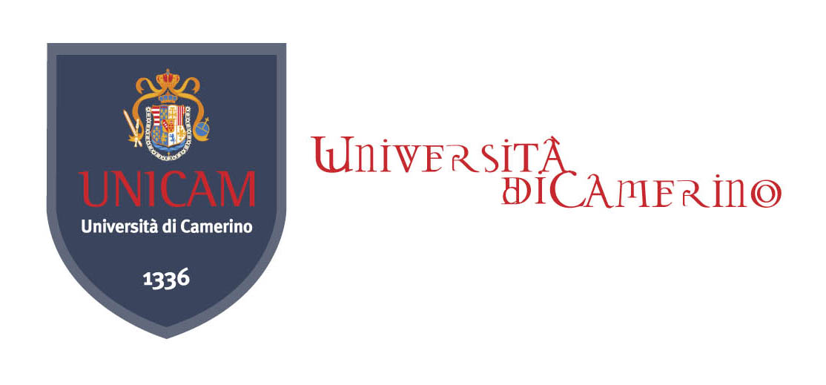

APPLICATION FORM

N. 7 GRANTS FOR STUDENTS IN DOUBLE/JOINT DEGREE IN EU AND NON EU COUNTRIES

Section 1 : Personal Data
Name
Surname NoNome…………………………………………………………………………….*Nome…………………………………………………………….
Date and place of birth Sex:
Nationality
Italian Fiscal Code fiscaleFiscale:………………………………………………│_│_│_│_│_│_│_│_│_│_│_│_│_│_│_│_│………………………………………..
Residence (Town): Zip code
Address
Mobile phone :
mo*Tel...............................………………………………………………………...…*Cell……………….……………………...........................................
e-mail:
Student ID Year of study
Degree course you are currently enrolled | - Bachelor in …
Degree course you are currently enrolled | - Master in …….
Degree course you are currently enrolled | - A one-tier course in

University in Double/joint degree
University | Country | Study period |  | Stay period  (no. of months)
 |  | I sem. | II sem.

Language competence

Please specify kind of language knowledge held: (higher than B1 level)
1. 3.

2. 4.

The undersigned candidate declares that all the requirements of the present call are satisfied and encloses the following documents:
- a copy of the on-line student record book;
- self-declaration of language knowledge (level of competence)*
- motivation questionnaire

Lacking an international language certificates, the committee reserves the right to determine the knowledge of the language through a placement test or oral test.

Section 2: ACADEMIC BACKGROUND

The undersigned candidate
hereby declares to be enrolled in the
first year of degree course:
second
third
fourth
fifth
n° …….. fuori corso.

□ BACHELOR in ……………………………………………………………………………………………

and to have achieved credits numbers:…………
with weighted average mark of …......../30.

□ MASTER in …………………………………………………………………………

and to have achieved credits numbers:…………
with weighted average mark of …......../30.

□ ONE-TIER DEGREE in …………………………………………………………………………

and to have achieved credits numbers:…………
with weighted average mark of …......../30.

Section 3: MOTIVATIONAL QUESTIONNAIRE

- Please explain the reasons of choosing a double/joint degree course
………………………………………………………………………………………………………………………………………………………………………………………………………………………………………………………………………………………………………………………………………………………………………………………………………………………………………………………………………………………………………………………………………………………………………………………………………………………………………………………………………………………………………………………………………………………………………………………………………………………………………………………………………………………………………………………………………………………………………………………………………………………………………………………………………………………………………………………………………………………………………………………………………………………………………………………………………………………………………………………………………………………………………………………………………………………………………………………………………………………………………………………………
- Which courses are you interested in attending at your host University for achieve double/joint degree? Please shortly describe your study plan …………………………………………………………………………………………………………………………………………………………………………………………………………………………………………………………………………………………………………………………………………………………………………………………………………………………………………………………………………………………………………………………………………………………………………………………………………………………………………………………………………………………………………………………………………………………………………………………………………………………………………………………………………………………………………………………………………………………………………………………………………………………………………………………………………………………………………………………………………………………………………………………………………………………………………………………………………………………………………………………………………………………………………………………………………………………………………………………………………………………………………………………………………………………………………………………………………………………………………………………………………………………………………………………………………………………………………………………………………………………………………………………………………………………………………………………………………………………………………………………………………………………………………………………………………………………………………………………………………………………………………………………………………………………………………………………………………………………………………………………………………………………………………………………………………………………

- Do you have already a good knowledge of the English language or of your host University teaching language? Please describe what language have you been studying and the current level of your knowledge. Please describe how do you intend to improve it- if necessary.
……………………………………………………………………………………………………………………………………………………………………………………………………………………………………………………………………………………………………………………………………………………………………………………………………………………………………………………………………………………………………………………………………………………………………………………………………………………………………
- Have you ever studied/ worked abroad? Please, shortly describe your past experience.
……………………………………………………………………………………………………………………………………………………………………………………………………………………………………………………………………………………………………………………………………………………………………………………………………………………………………………………………………………………………………………………………………………………………………………………………………………………………………

SELF DECLARATION
Under the Law D.P.R. n. 403 del 20/10/98 and its further integrations and modifications the candidate must be aware that any untrue declarations will cause the cancellation of any right and they will be judged as a criminal act.

According to D. lgs. No 196/ 2003 UNICAM is authorized to process and transmit the personal data for institutional purposes.

Date___________________________ Signature __________________________________

